**Chapter 7**

**Second-Order Differential Equations**

**7.3 Applications**

**Section Exercises**

1. A mass weighing 4 lb stretches a spring 8 in. Find the equation of motion if the spring is released from the equilibrium position with a downward velocity of 12 ft/sec. What is the period and frequency of the motion?

Answer:  period frequency 

1. A mass weighing 2 lb stretches a spring 2 ft. Find the equation of motion if the spring is released from 2 in. below the equilibrium position with an upward velocity of 8 ft/sec. What is the period and frequency of the motion?

Answer:   period frequency

1. A 100-g mass stretches a spring 0.1 m. Find the equation of motion of the mass if it is released from rest from a position 20 cm below the equilibrium position. What is the frequency of this motion?

Answer:   period frequency

1. A 400-g mass stretches a spring 5 cm. Find the equation of motion of the mass if it is released from rest from a position 15 cm below the equilibrium position. What is the frequency of this motion?

Answer:   period frequency

1. A block has a mass of 9 kg and is attached to a vertical spring with a spring constant of 0.25 N/m. The block is stretched 0.75 m below its equilibrium position and released.
   1. Find the position function  of the block.
   2. Find the period and frequency of the vibration.
   3. Sketch a graph of .
   4. At what time does the block first pass through the equilibrium position?

Answer: a.  b. period  frequency  c.

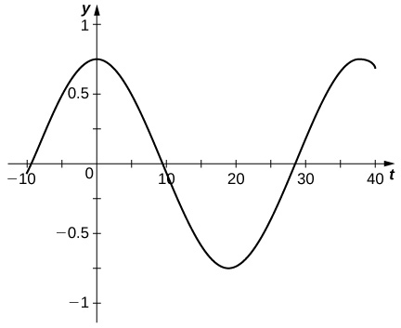

d. 

1. A block has a mass of 5 kg and is attached to a vertical spring with a spring constant of 20 N/m. The block is released from the equilibrium position with a downward velocity of 10 m/sec.
2. Find the position function  of the block.
3. Find the period and frequency of the vibration.
4. Sketch a graph of .
5. At what time does the block first pass through the equilibrium position?

Answer: a.  b. period , frequency c.

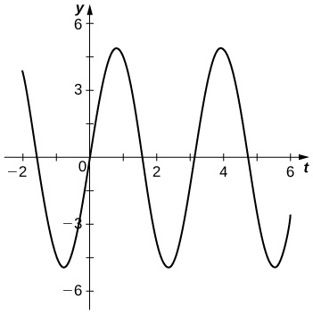

d. 

1. A 1-kg mass is attached to a vertical spring with a spring constant of 21 N/m. The resistance in the spring-mass system is equal to 10 times the instantaneous velocity of the mass.
   1. Find the equation of motion if the mass is released from a position 2 m below its equilibrium position with a downward velocity of 2 m/sec.
   2. Graph the solution and determine whether the motion is overdamped, critically damped, or underdamped.

Answer: a.  b. overdamped

1. An 800-lb weight (25 slugs) is attached to a vertical spring with a spring constant of 226 lb/ft. The system is immersed in a medium that imparts a damping force equal to 10 times the instantaneous velocity of the mass.
   1. Find the equation of motion if it is released from a position 20 ft below its equilibrium position with a downward velocity of 41 ft/sec.
   2. Graph the solution and determine whether the motion is overdamped, critically damped, or underdamped.

Answer: a.  b. underdamped

1. A 9-kg mass is attached to a vertical spring with a spring constant of 16 N/m. The system is immersed in a medium that imparts a damping force equal to 24 times the instantaneous velocity of the mass.
   1. Find the equation of motion if it is released from its equilibrium position with an upward velocity of 4 m/sec.
   2. Graph the solution and determine whether the motion is overdamped, critically damped, or underdamped.

Answer: a.  b. critically damped

1. A 1-kg mass stretches a spring 6.25 cm. The resistance in the spring-mass system is equal to eight times the instantaneous velocity of the mass.
2. Find the equation of motion if the mass is released from a position 5 m below its equilibrium position with an upward velocity of 10 m/sec.
3. Determine whether the motion is overdamped, critically damped, or underdamped.

Answer: a.  b. critically damped

1. A 32-lb weight (1 slug) stretches a vertical spring 4 in. The resistance in the spring-mass system is equal to four times the instantaneous velocity of the mass.
2. Find the equation of motion if it is released from its equilibrium position with a downward velocity of 12 ft/sec.
3. Determine whether the motion is overdamped, critically damped, or underdamped.

Answer: a.  b. overdamped

1. A 64-lb weight is attached to a vertical spring with a spring constant of 4.625 lb/ft. The resistance in the spring-mass system is equal to the instantaneous velocity. The weight is set in motion from a position 1 ft below its equilibrium position with an upward velocity of 2 ft/sec. Is the mass above or below the equation position at the end of  sec? By what distance?

Answer: ft below

1. A mass that weighs 8 lb stretches a spring 6 inches. The system is acted on by an external force of  lb. If the mass is pulled down 3 inches and then released, determine the position of the mass at any time.

Answer: 

1. A mass that weighs 6 lb stretches a spring 3 in. The system is acted on by an external force of  lb. If the mass is pulled down 1 inch and then released, determine the position of the mass at any time.

Answer: 

1. Find the charge on the capacitor in an *RLC* series circuit where H,  F, and  V. Assume the initial charge on the capacitor is 7 C and the initial current is 0 A.

Answer: 

1. Find the charge on the capacitor in an *RLC* series circuit where H,  F, and  V. Assume the initial charge on the capacitor is 0.001 C and the initial current is 0 A.

Answer: 

1. A series circuit consists of a device where H,  F, and  V. If the initial charge and current are both zero, find the charge and current at time *t*.

Answer: 

1. A series circuit consists of a device where H,  F, and  V. If the initial charge on the capacitor is 0 C and the initial current is 18 A, find the charge and current at time *t*.

Answer: 

**Student Project**

**Landing Vehicle**

1. The lander has a mass of 15,000 kg and the spring is 2 m long when uncompressed. The lander is designed to compress the spring 0.5 m to reach the equilibrium position under lunar gravity. The dashpot imparts a damping force equal to 48,000 times the instantaneous velocity of the lander. Set up the differential equation that models the motion of the lander when the craft lands on the moon.

Answer: To find the spring constant, we have



Then 

1. Let time  denote the instant the lander touches down. The rate of descent of the lander can be controlled by the crew, so that it is descending at a rate of 2 m/sec when it touches down. Find the equation of motion of the lander on the moon.

Answer: The differential equation in part 1 has general solution



Applying the initial conditions  and  we find



1. If the lander is traveling too fast when it touches down, it could fully compress the spring and “bottom out.” Bottoming out could damage the landing craft and must be avoided at all costs. Graph the equation of motion found in part 2. If the spring is 0.5 m long when fully compressed, will the lander be in danger of bottoming out?

Answer:

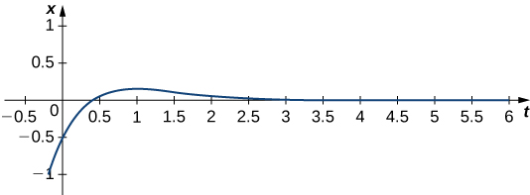

The spring is 2 m long, and is compressed 0.5 m at equilibrium. When fully compressed, the spring is 0.5 m long. Therefore, if the spring is compressed 1 m beyond equilibrium, the lander will bottom out. The graph shows the spring compresses less than 0.5 m beyond equilibrium, so the lander is in no danger of bottoming out on the moon.

1. Assuming NASA engineers make no adjustments to the spring or the damper, how far does the lander compress the spring to reach the equilibrium position under Martian gravity?

Answer: Gravity on Mars is 3.7 m/s2. So we have



On Mars, the spring is compressed 1.156 m at equilibrium.

1. If the lander crew uses the same procedures on Mars as on the moon, and keeps the rate of descent to 2 m/sec, will the lander bottom out when it lands on Mars?

Answer: The spring and damper have not changed, and the lander still has the same mass so the same differential equation used to model lander motion on the moon can be used for Mars. The general solution also remains the same



Our initial conditions are  and , so the equation of motion for the lander on Mars is



Recall the lander will bottom out if the spring is compressed 1.5 m overall. On Mars, the spring is already compressed 1.156 m at equilibrium, so if it is compressed only 0.344 m beyond equilibrium, the lander will bottom out. Fortunately, graphing the equation of motion we see the spring does not compress beyond equilibrium, so the lander will not bottom out on Mars.

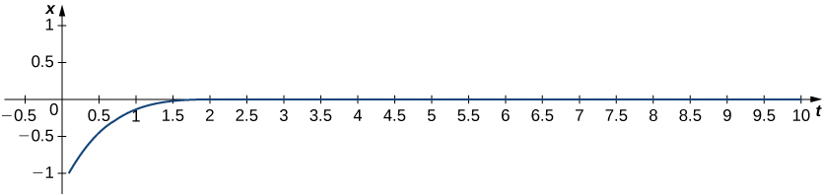

1. What adjustments, if any, should the NASA engineers make to use the lander safely on Mars?

Answer: No changes are needed. (If the lander was in danger of bottoming out on Mars, we could have recommended NASA use a stiffer spring, a more powerful damper, or slow the landing speed of the craft.)

**Student Project**

**Resonance**

1. Consider the differential equation  Find the general solution. What is the natural frequency of the system?

Answer: The general solution is  The natural frequency is 

1. Now suppose this system is subjected to an external force given by  Solve the initial-value problem   

Answer: 

1. Graph the solution. What happens to the behavior of the system over time?

Answer:

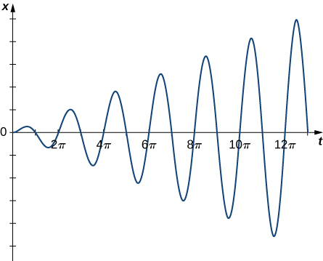

This file is copyright 2016, Rice University. All Rights Reserved.